**Master Functional Document**

|  |  |
| --- | --- |
| **Application** | NGERP - Centra |
| **Service Bundle** | Master Management |
| **Service Request** | Manage Item List |

**Description :**

Manage Item list is to categorise partners as global category.

**Workflow Process :**

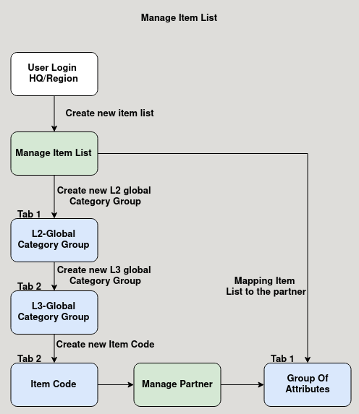

**Business Rules :**

* user can login as HQ or Region to create a new item list.
* The item list is used to categorise the partner as L1, L2, L3 global category.
* This item list is mapped in the manage partner master group of attributes tab.